Careers Lesson Plan – Senior
Student Worksheet

Lesson Aim
This workshop will:
- Help you explore your Career Aspirations and Ambitions – what type of Roles, Careers and Industries interest you
- Increase your understanding of the different Routes into the World of Work and key Employability Skills
- Learn how to develop your skills and strengths whilst unlocking your Career Aspirations

Before You Start
- If you are confident of your Career Aspirations and Ambitions post A level go to Activity 1, then move onto Activity 3 and so on.
- If you are still unsure of what career path is right for you – don’t worry you’re not alone. 28% of 15 – 18 year olds said that they didn’t know what they wanted to do after leaving school. Go to Activity 2 then move onto Activity 3 and so on.
Activity 1 (10 mins)
- List 3 Career Aspirations and Ambitions in the table below

Your Career Aspirations | Why have you selected this Role/ Career / Industry to work in?
1.

2.

3.

Activity 2 (10 mins)
To help provide you with some more information on the different career paths available, please click on the links below. These are only a few of the resources available to you – ask your Career Leader for more or search online.
- Researching specific career options: https://www.prospects.ac.uk/careers-advice/getting-a-job/how-to-choose-a-career
- Take the Job Match Quiz: https://www.prospects.ac.uk/job-match (Prospects will ask you to register first)
Activity 3 (8 mins)
There are many different routes into the world of work which can help you reach your career ambitions and aspirations. To help guide you we have outlined some key information and case studies below.
Routes into the World of Work – Overview
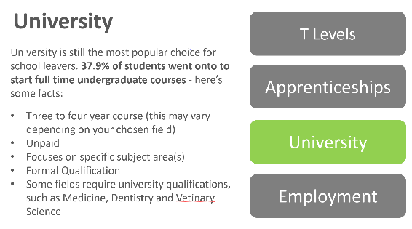
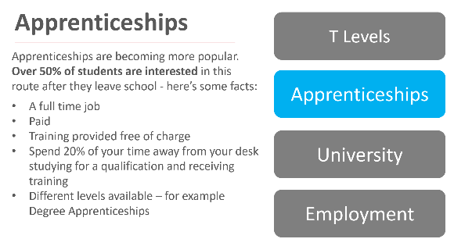
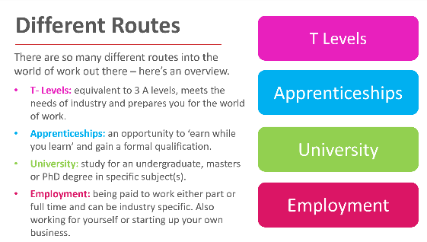

Routes into The World of Work - Case Studies
To help bring these different routes to life, click on the links below to hear other young people share their career journeys.
- Meet Wesleyan’s Work Experience Students here
- Meet Barclays Technology Graduates and Apprentices here
- Meet Nestle Digital Marketing Apprentice here

Activity 4 (8 mins)

Hopefully the information above detailing the different routes into the world of work has helped you. Use the box below to outline your preferred route based on Activity 1’s responses and explain why you have selected this option.

Your Career Aspirations | What’s your preferred Route for this Aspiration?
1.

2.

3.

Activity 5 (10 mins)

Now it’s time to reflect on your skills. Below are the 7 key Employability Skills employers look for when recruiting. Using the table below, rank them from your strongest to the least strong.
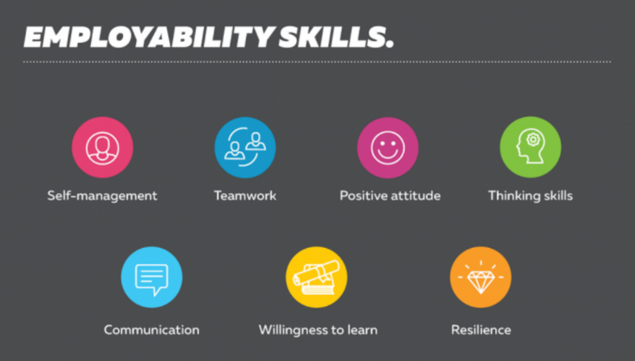

Ranking | Why have you placed this here?
- (Strongest Skill)

- (Least Strong Skill)

Activity 6 (10 mins)

Now, let’s look at your 3 least strong skills and think about ways you can develop these. Use the table below to write your answers.

Skill | How can you improve this skill?

Next Steps

Well done on completing the worksheet! We hope this has given you a good insight into your career journey and how you can use your skills to unlock your potential. After this workshop, it’s important to:

- Continue to reflect on ways to improve skills that you feel confident in and those you would like to strengthen.
- Speak to family, teachers and Career Leaders for advice. Also explore different career websites for further support.
- Remember that Career Aspirations and Ambitions are not set in stone – lots of people change their mind.

